8. Statistical Measures and Plot of Orientation Data
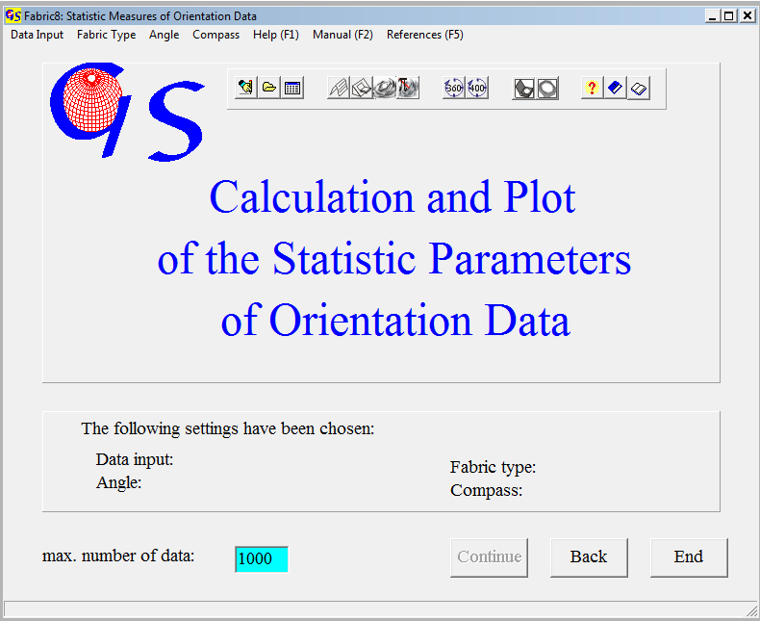
Fig. 1

This Program (Fig. 1) calculates the statistic parameters of spherically distri-buted orientation data and plots them in various projections. In addition eigen-values and eigenvectors of the orientation tensor are calculated. Menus and speed buttons of the start form are the same as in program 3. Input of data is also the same.

The following measures are calculated:
1. The degree of preferred orientation, R% (WALLBRECHER 1979, 1986):

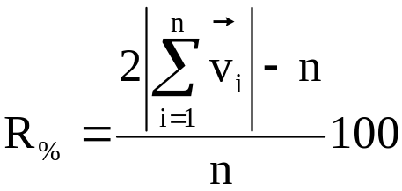

n = number of data, v_{i} = each measurement, written as a vector.

2. The estimate of the Concentration Parameter (WATSON 1966):

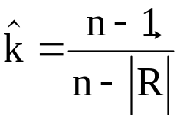

n = number of data, ⏐ ⏐ = Resultant length of the vector sum.

3. The Cone of Confidence for the orientation of the vector sum
(FISHER 1955):

Θ = arccos 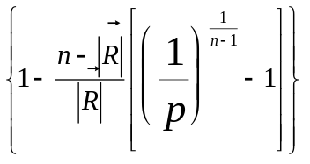

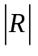 = Resultant length, p = probability of error (0.01, 0.5 oder 0.1), this equals a confidence of 99, 95 und 90%, which is chosen from a pull down menu and saved in “fabric7.ini”.

4. The Spherical Aperture (WALLBRECHER 1979, 1986):

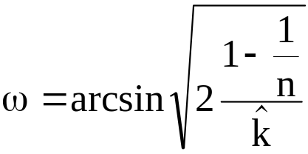

k = concentration parameter.

5. The Centre of Gravity:
is the direction of the vector sum. It is written as azimuth and direction of dip. The reference system for vectorisation is as follows:

+x → north
+y → east
+z down

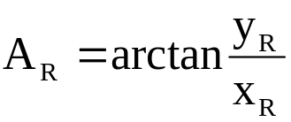

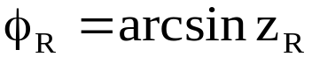

6. The eigenvalues are derived from the orientation matrix:

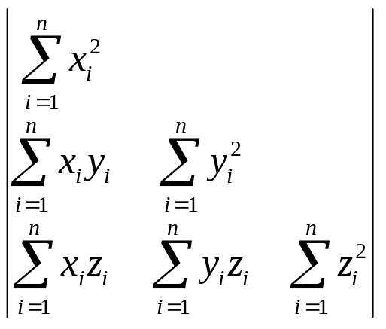

A measure of the Cylindricity of the distribution is derived from the relation of the eigenvalues. Values under 50%, represent cluster distributions, the others are girdle distributions (see explanations of program 17 “WOODCOCK Diagram”). The cylindricity is calculated like this:

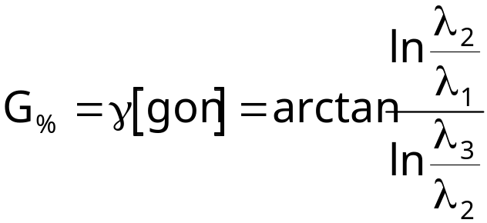
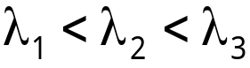 = Eigenvalues of the orientation matrix.

The Circular Aperture (WALLBRECHER 1986:168) is an angular measure for the length of a girdle distribution. It has the form

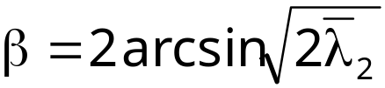

0° < β < 180°.

Fig 2 shows the evaluation of 30 linear data.

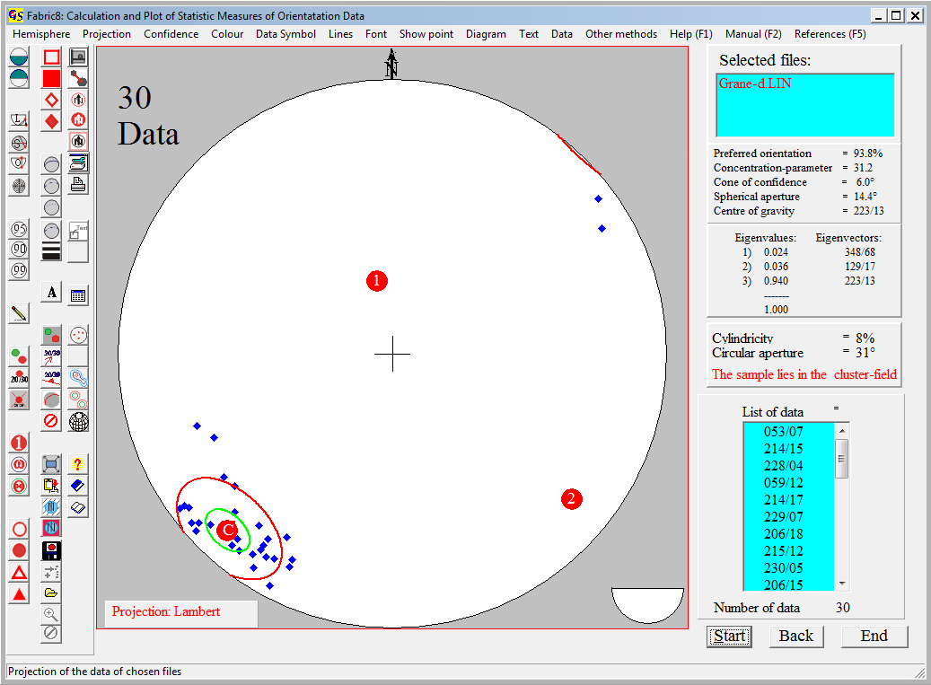
Fig. 2

The projection hemisphere, method of projection, colour of data points, eigenvectors, aperture, and cone of confidence, and the shape of data points and line style can be changed in the menu bar (s. Program 3). The menu "Confidence" (Fig. 3) sets the confidence level.

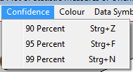
Fig. 3

The green small circle in Fig. 2 is the cone of confidence for 99%. The red small circle is the spherical aperture. The centre of both circles is the centre of gravity for the distribution. The red dots are the projections of the eigenvectors, the numbers indicate the indices of the eigenvalues. ‚S‘ is the centre of gravity. The statistic parameters are listed on the left side of the graph.
Fig. 4 shows the evaluation of a great circle distribution. The data set is the same as in program 4. Data are bedding planes of a folded region.
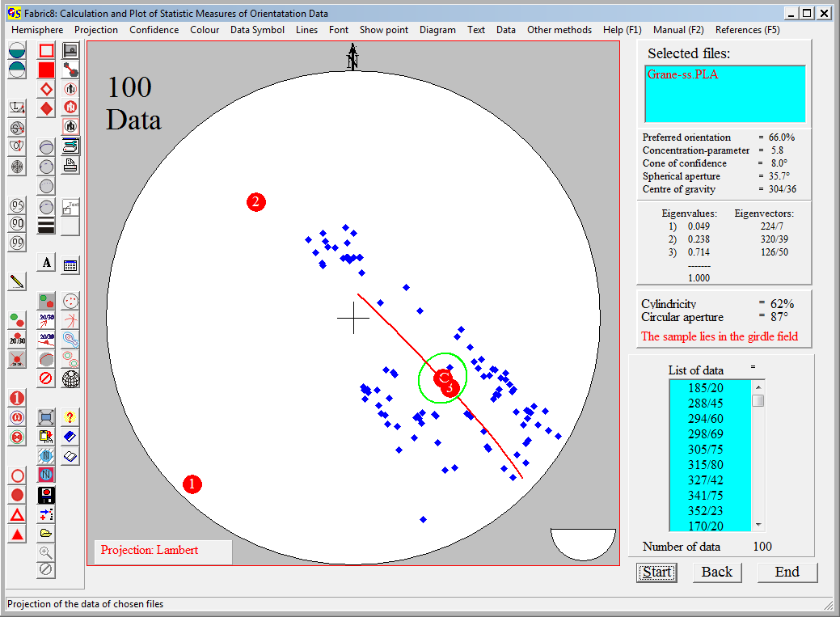
Fig. 4

The partial great circle defines orientation and size of the circular aperture.

With the menu "Other methods" you can jump to the other Programs which use the same type of data.
All other menus, not mentioned here, are described in Program 3.

